

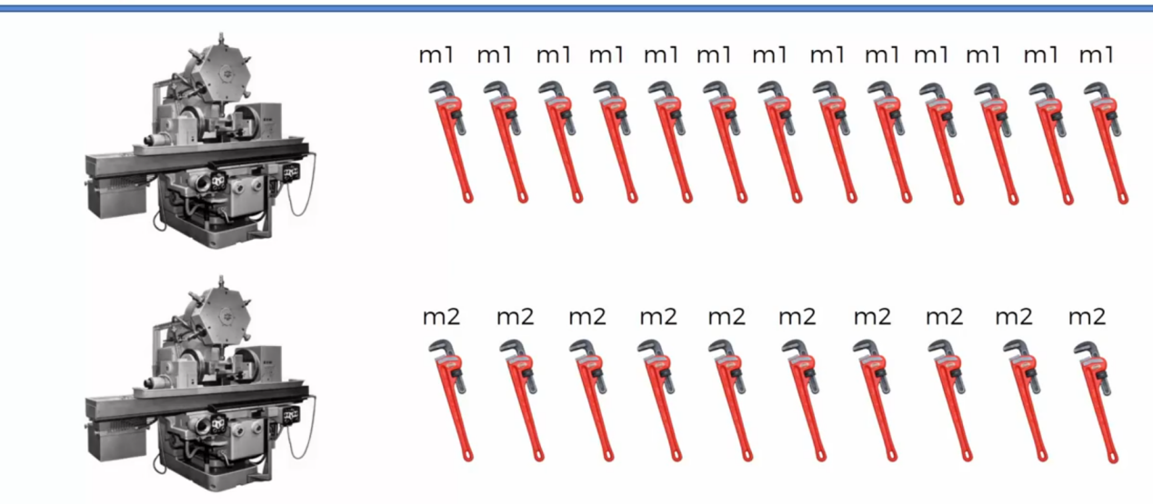

Let’s Assume, We have Two machines. Where Machine 1 is producing n1 no. Of Wrenches and Machine 2 producing n2 number of Wrenches.

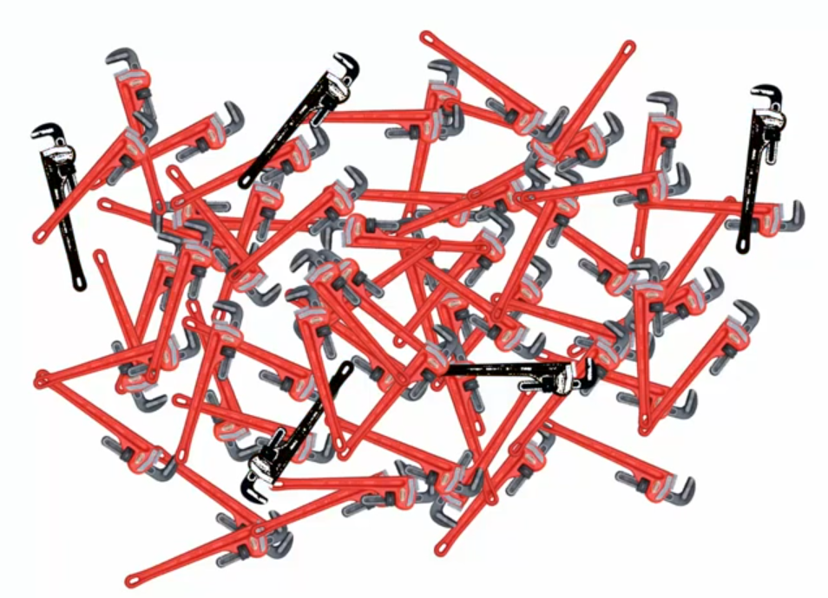

At the End of Day, we found that, Few Wrenches are Defective and can’t be sold in market. But now, all wrenches are mixed and all the wrenches looks same. So, it’s difficult to find the machine which is producing the defective Wrenches.

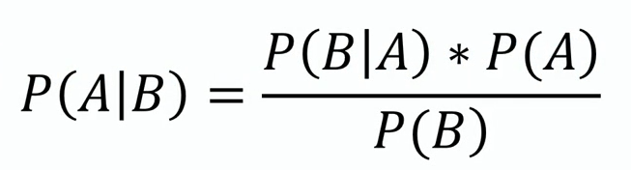

The Above formula of finding the probability is Bayes Theorem.

Given data,

1. Let’s Assume, Machine 1 is producing 30 Wrenches/hr and Machine 2 is producing 20 Wrenches/hr( n1 = 30 Wr/ hr and n2 = 20 Wr/hr. )
2. At the End of Day, 1% of Wrenches are defective among Total. Among 1% of defective wrenches -> 0.5 % is from Machine1 and 0.5% is from Machine 2.

Ans:-

Now, we have 3 Categories of probabilities as following.

Category 1 - Probability of Defect Wrench = 1%. P( Defective ) = 1% = 1/100 = 0.01

Category 2 :-

Probability of (All -> Defective and Non- Defective) wrench coming from Machine 1 =

P( Machine 1 | Total ) = P( Machine 1 ) 30/50 = 0.60

Probability of (All -> Defective and Non- Defective) wrench coming from Machine 2 =

P( Machine 2 | Total ) = P( Machine 2 ) = 20/50 = 0.40

Category 3 :-

Probability of only Defective wrenches from Machine1 -> P( Machine1 | Defective ) = 50% = 0.50

If 10 wrenches are Defective.

M1/ Defective = 50% of Defective = 50% of 10 = 5 Wrenches

M2/ Defective = 50% of Defective = 50% of 10 = 5 Wrenches

Probability of only Defective wrenches from Machine2 -> P( Machine2 | Defective ) = 50% = 0.50.

Summary :- We have defective Probability :- **P( Defective|Total ) = P( Defective ) = 1% = 0.0.1** , **P( Machine2 ) = 0.4** and **P( Machine2|Defective ) = 0.5** . i.e., **Out of defective, how many are from Machine2**.

Objective :- We have to find the probability of producing the **defective wrenches only from machine 2**. Which means, we have to find the p( Defective | Machine 2 ) = ?

Our Formula : -

**A = Defective and B = Machine 2**.

**P( Defective | Machine 2 ) = [ P( Machine2 | Defective ) * P( Defective ) ] / P( Mahine2 )**

**P( Defective | Machine 2 ) =** **[ 0.5 * 0.01 ] / 0.4 = 0.005/ 0.4 = 0.0125**

Note : - If a machine2 is producing 10,000 parts then, 125 part of Machine 2 will be Defective.

Similarly for Machine1 ,

**P( Defective|Total ) = P( Defective ) = 1% = 0.01** , **P( Machine1 ) = 0.6** and **P( Machine2|Defective ) = 0.5**

**P( Defective | Machine 1 ) = [ P( Machine1 | Defective ) * P( Defective ) ] / P( Mahine1 )**

**P( Defective | Machine 1 ) =** **[ 0.5 * 0.01 ] / 0.6 = 0.005/ 0.6 = 0.0083333333333333‬ = 0.0084**

If a Machine 1 is producing 10,000 parts then, 84 part of Machine 1 will be Defective.

Let’s Take Another Example,

Ex 2 :- 1000 fruits we have. Out of which 400 are apple P( Apple ) = 0.4 and 600 are mango P( Mango ) = 0.6 . Where 5% is defective fruit P( Defective ) = 5% . **Among defective fruits, 60% are apple-> P( Apple | Defective ) and 40% are mangoes -> P( Mango | Defective ).**

ple|defective ) = 60% = 0.6

P( Mango|defective ) = 40% = 0.4

We have to Find, Out of Mangoes how many are defectives -> P( Defective | Mango ) and

P( Defective | Apple )= ?

1. P( Defective | Mango ) = **[ P( Mango | Defective ) * P( Defective ) ] / P( Mango )**

**= [ 40% * 5% ] / 60%**

**= [ 0.4 * 0.05 ] / 0.6**

**= 0.0025 / 0.6 = 0.03333333 = 0.034**

1. P( Defective | Apple ) = **[ P( Apple | Defective ) * P( Defective ) ] / P( Apple )**

**= [ 60% * 5% ] / 40%**

**= [ 0.6 * 0.05 ] / 0.4**

**= 0.3 / 0.4 = 0.075**